TI 23 – 05 Technology Example – FLIR Emissions monitoring – Fixed Camera
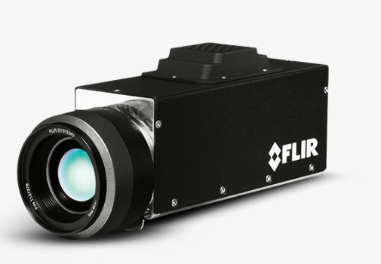
The FLIR G300 a optical gas imaging (OGI) camera visualizes gas, so you can monitor installations in remote or hazardous areas for gas leaks. Through continuous monitoring, you can catch dangerous, costly hydrocarbon or volatile organic compound (VOC) leaks and take immediate action. OGI cameras are widely used in industrial settings, such as natural gas processing plants and offshore platforms.
- DETECTS A VARIETY OF GASES
Benzene, Ethanol, Ethylbenzene, Heptane, Hexane, Isoprene, Methanol, MEK, MIBK, Octane, Pentane, 1-Pentene, Toluene, Xylene, Butane, Ethane, Methane, Propane, Ethylene, and Propylene.
- EASY TO CONTROL
The G300 a is easily controlled over Ethernet from a safe distance, and can be integrated in a TCP/ IP network.
- SEE EVEN THE SMALLEST LEAKS
The cooled 320 x 240 detector produces crisp thermal images with a high sensitivity mode for detecting the smallest leaks.

Link to Vendors website for further information:
FLIR G300 a Optical Gas Imaging Camera For Gas Leak Detection | Teledyne FLIR

